Project Design Phase
Solution Architecture

Date | 27 June 2025
Team ID | LTVIP2025TMID36160
Project Name | Citizen AI – Intelligent Citizen  Engagement Platform
Maximum Marks | 4 Marks

Solution Architecture:
Solution architecture is a complex process, with many sub-processes, that bridges the gap between business problems and technology solutions. Solution architecture defines how software systems will support business goals by aligning technical strategies with real-world needs.
It ensures the selected technologies, tools, and structures are optimal for solving the identified problems.
It involves planning system components, integrations, data flow, and scalability from both technical and business perspectives.
Ultimately, it acts as a blueprint to guide development, reduce risks, and ensure efficient delivery of the solution.
Its goals are to:
- Find the best tech solution to solve existing business problems.
- Describe the structure, characteristics, Behavior, and other aspects of the software to project stakeholders.
- Define features, development phases, and solution requirements.
- Provide specifications according to which the solution is defined, managed, and delivered.

Example - Solution Architecture Diagram:
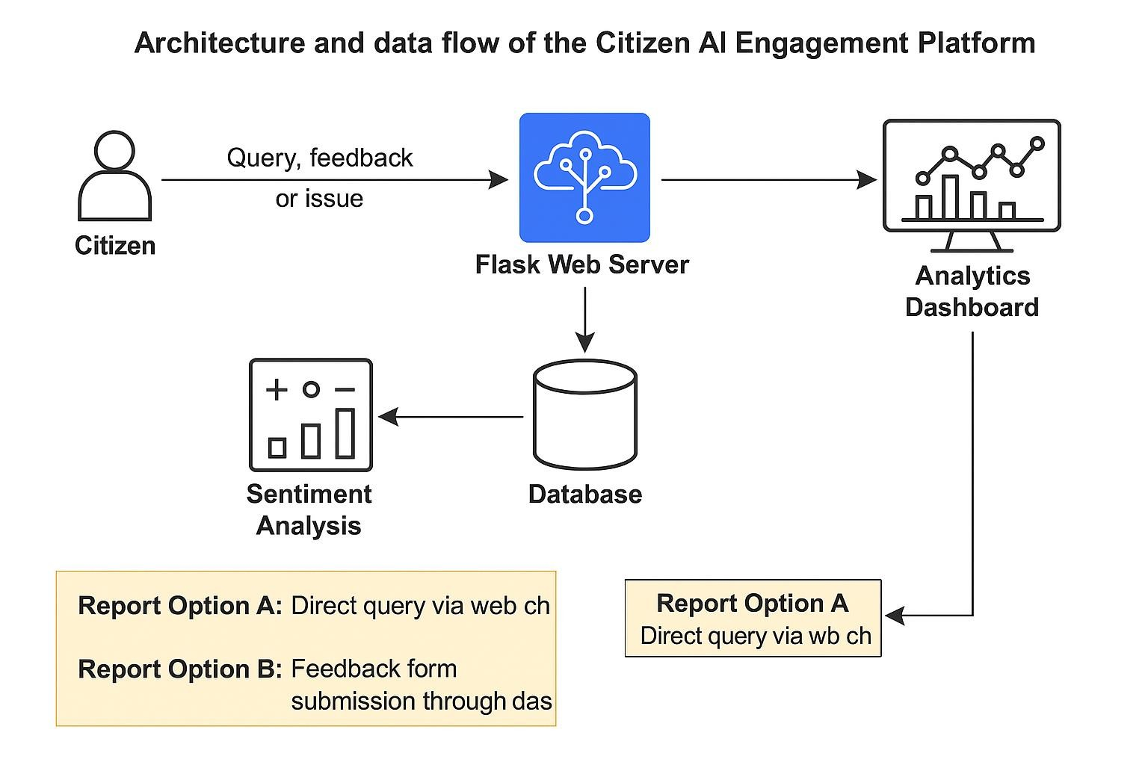

The best tech solution based on both images is a cloud-based AI-powered citizen engagement system that integrates:
- IBM Watson/Granite for real-time sentiment analysis and natural language understanding.
- Flask backend to manage API calls and orchestrate services.
- NoSQL database for flexible storage of user interactions and sentiment results.
- Analytics Data Store & Dashboard for visualizing trends and feedback insights.
This solution addresses the business need for efficient, automated, and data-driven public service engagement, improving response quality, transparency, and citizen satisfaction.
The Citizen AI Engagement Platform is a modular, cloud-integrated web application designed to streamline citizen interaction with government services.
The Citizen AI Platform follows a layered architecture with a user-friendly frontend, Flask backend, IBM Watson/Granite AI integration, and NoSQL/analytics-based storage.
It is scalable, cloud-ready, and supports real-time, AI-driven responses, with a modular design and secure data handling.
The system processes citizen queries, performs sentiment analysis, stores interactions, and updates a live dashboard for decision-makers.
Key features include 24/7 support, real-time governance insights, improved transparency, and data-driven public service enhancements.

Features: Real-time chatbot, sentiment analysis, feedback submission, and dynamic analytics dashboard.
Development Phases: Requirement gathering → UI/Backend development → AI integration → Testing → Deployment.
Solution Requirements: Python Flask, IBM Watson API, NoSQL DB, cloud hosting (e.g., IBM Cloud or AWS), and a web frontend framework.
The solution is defined based on Agile methodology, with clear user stories and prioritized backlogs.
It is managed using sprint-based tracking, burndown charts, and velocity metrics to ensure timely progress.
Delivery follows CI/CD practices with regular testing, stakeholder reviews, and deployment to a secure cloud environment.

